**Spotify’s Gender Demographics in (%):**

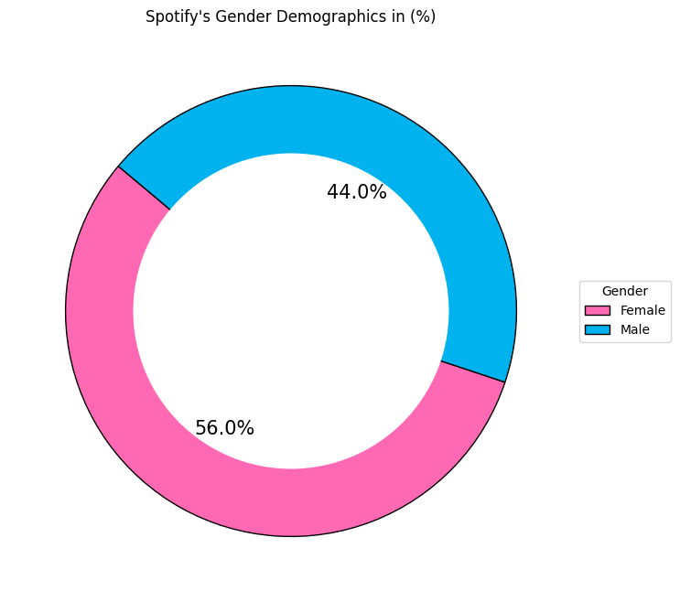

Detailed explanation:

The donut chart shows that **56%** of Spotify users are **female**, while **44%** are **male**, reflecting a **slight gender imbalance** in the user base. The visual representation with a donut chart allows for easy comparison of proportions. The color distinction between male and female users helps illustrate Spotify’s gender distribution, demonstrating that the platform appeals to both demographics, with a slight advantage in female engagement.

Key statement:

The higher percentage of female users may suggest that Spotify’s playlists, ease of use, and diverse content selection appeal more to women. It could also reflect broader trends in digital music consumption.